Decagonal Trapezohedron

Definition
# Source: AI Source: Provided by: [Data Path: Persons Table -> ID Column: 1, Name_En Column: Motasem Essam] -> From: [ChatGPT] on [7/25/2026]
A Decagonal Trapezohedron is a convex polyhedron formed by 20 congruent kite-shaped faces arranged symmetrically around a central axis.
It has two opposite apexes: one at the top and one at the bottom. The faces are arranged in two groups of ten, with each group meeting at one apex. The upper and lower groups are connected through two staggered rings of vertices.
It is also called a Decagonal Deltohedron or Decagonal Antidipyramid. It is the dual polyhedron of a decagonal antiprism.
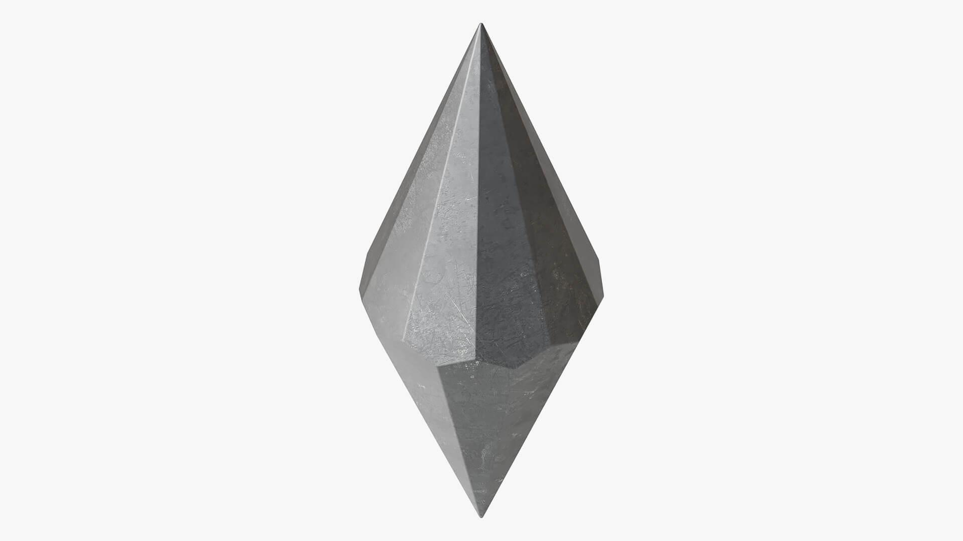

Simple Definition
# Source: AI Source: Provided by: [Data Path: Persons Table -> ID Column: 1, Name_En Column: Motasem Essam] -> From: [ChatGPT] on [7/25/2026]
A Decagonal Trapezohedron is a solid with:
- 20 identical kite-shaped faces.
- 40 edges.
- 22 vertices.
- Two opposite pointed ends.
- A tenfold arrangement around its central axis.

Geometric Structure
# Source: AI Source: Provided by: [Data Path: Persons Table -> ID Column: 1, Name_En Column: Motasem Essam] -> From: [ChatGPT] on [7/25/2026]
The Decagonal Trapezohedron consists of:
- Two opposite apexes: One upper apex and one lower apex.
- Two staggered vertex rings: Each ring contains 10 vertices.
- 20 kite-shaped faces: Ten upper kites and ten lower kites.
- A central axis: Passing vertically through both apexes and the center of the solid.
The two rings are rotated relative to one another, producing the twisted arrangement of the kite-shaped faces.

Face Structure
# Source: AI Source: Provided by: [Data Path: Persons Table -> ID Column: 1, Name_En Column: Motasem Essam] -> From: [ChatGPT] on [7/25/2026]
A Decagonal Trapezohedron has 20 congruent kite-shaped faces.
- Each face is a quadrilateral.
- Each face has two pairs of adjacent equal sides.
- The faces are arranged in a twisted pattern around the central axis.
- Ten faces meet at the upper apex.
- Ten faces meet at the lower apex.
Important: Despite its name, a trapezohedron does not have trapezoid-shaped faces. Its faces are kites.

Edge Structure
# Source: AI Source: Provided by: [Data Path: Persons Table -> ID Column: 1, Name_En Column: Motasem Essam] -> From: [ChatGPT] on [7/25/2026]
A Decagonal Trapezohedron has 40 edges.
Its edges can be grouped into two categories:
- 20 shorter edges.
- 20 longer edges.
Each edge is shared by exactly two kite-shaped faces.

Vertex Structure
# Source: AI Source: Provided by: [Data Path: Persons Table -> ID Column: 1, Name_En Column: Motasem Essam] -> From: [ChatGPT] on [7/25/2026]
A Decagonal Trapezohedron has 22 vertices:
- 2 apex vertices: one at the top and one at the bottom.
- 10 vertices in the upper ring.
- 10 vertices in the lower ring.
The vertex arrangement is:
- Each apex is connected to 10 surrounding vertices.
- Each of the 20 ring vertices is shared by 3 faces.
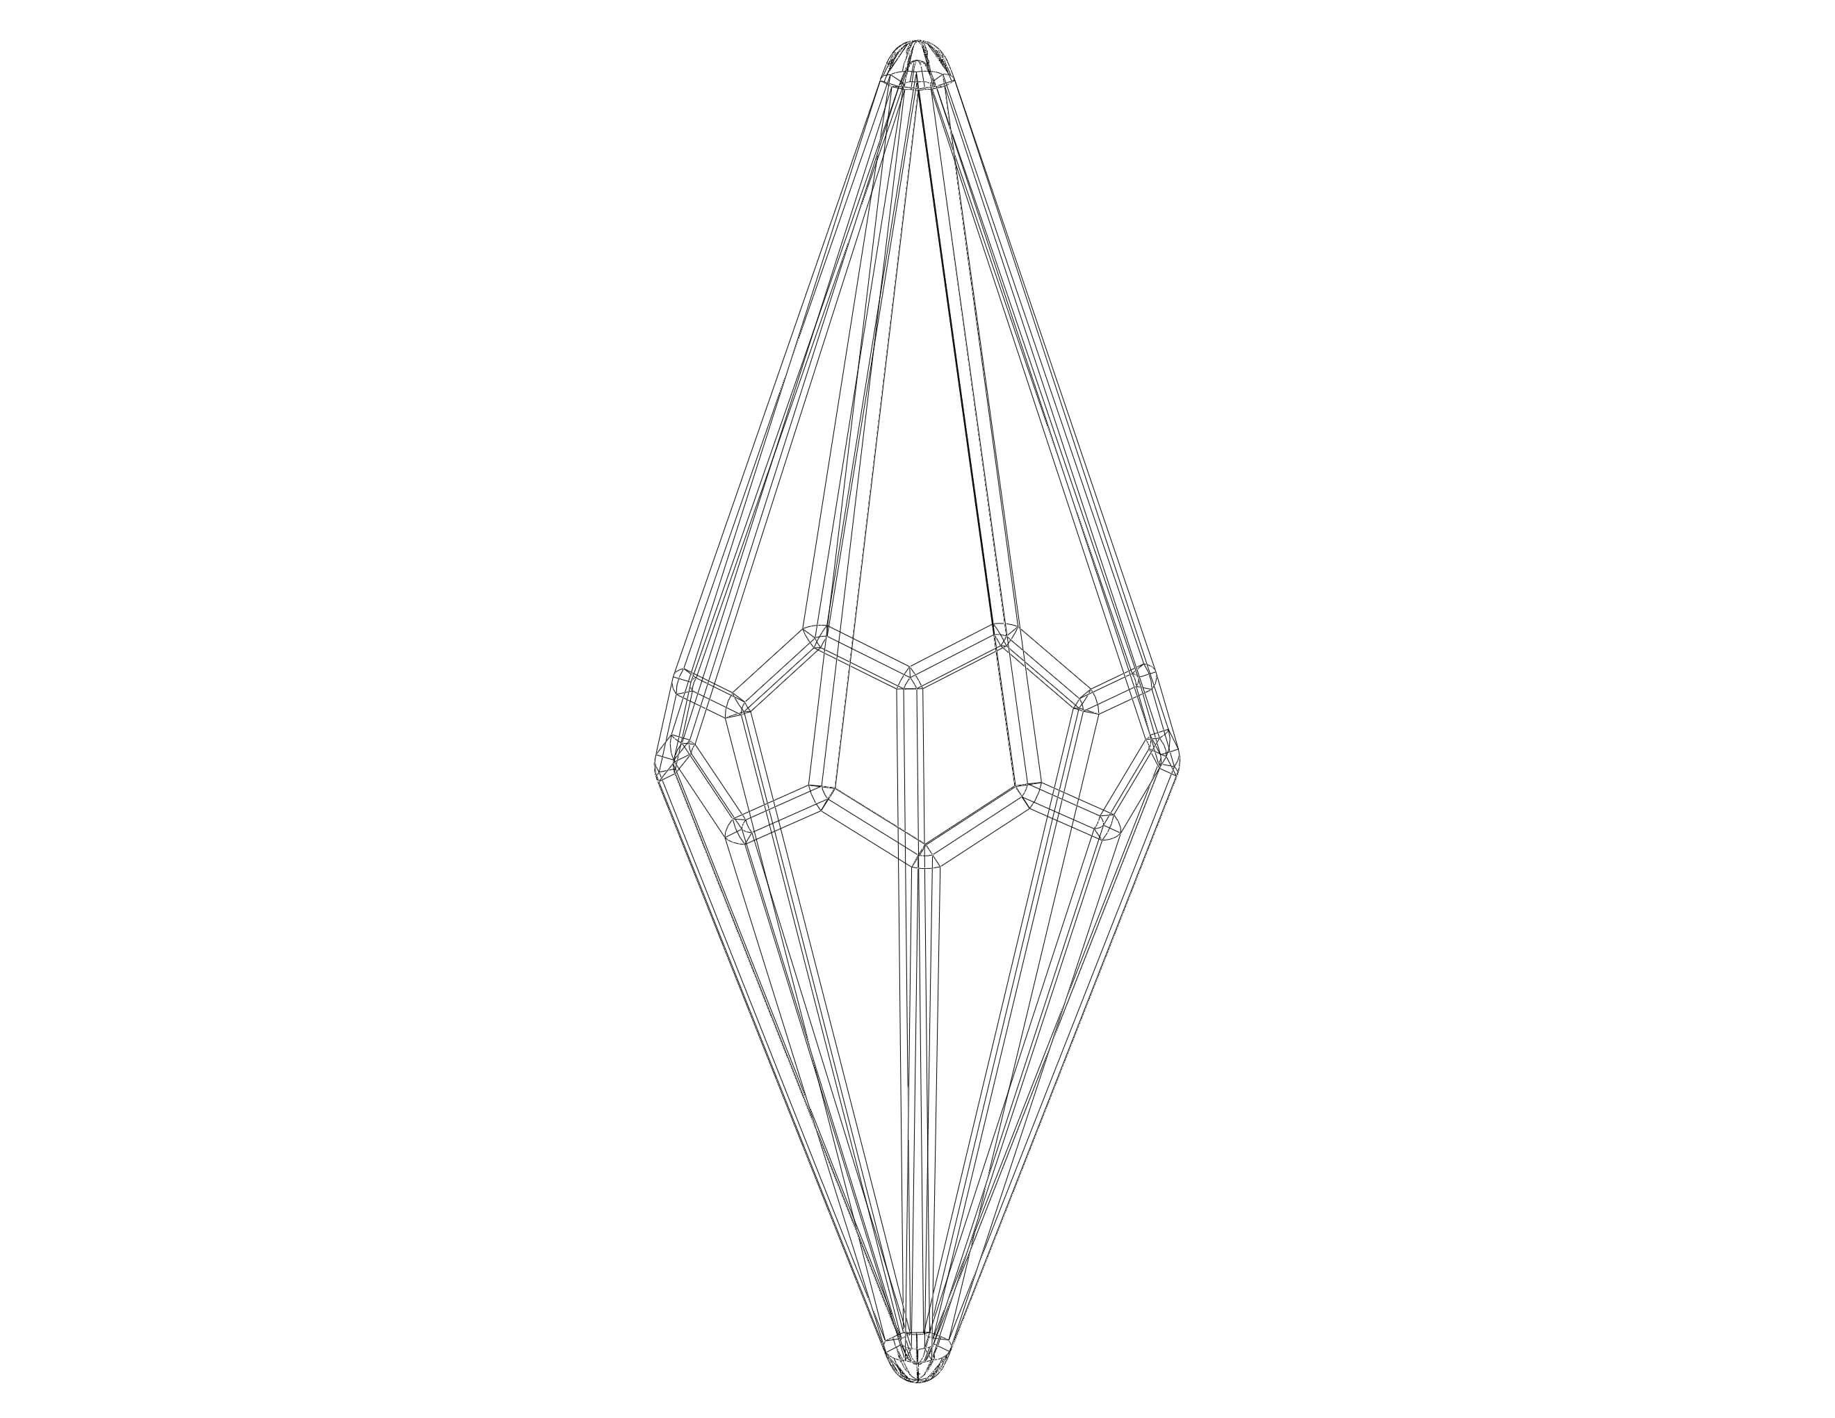

Mathematical Properties
# Source: AI Source: Provided by: [Data Path: Persons Table -> ID Column: 1, Name_En Column: Motasem Essam] -> From: [ChatGPT] on [7/25/2026]
The Decagonal Trapezohedron follows the general formulas for an n-gonal trapezohedron, where $n=10$.

Property | Formula | Result
Faces (F) | $$2n$$ | 20
Edges (E) | $$4n$$ | 40
Vertices (V) | $$2n+2$$ | 22
Euler's formula:
$$V-E+F=2$$
Substituting the values:
$$22-40+20=2$$
Therefore, the Decagonal Trapezohedron satisfies Euler's formula.

Face Incidence
# Source: AI Source: Provided by: [Data Path: Persons Table -> ID Column: 1, Name_En Column: Motasem Essam] -> From: [ChatGPT] on [7/25/2026]
The face incidence describes how faces meet at the vertices.
- At the upper apex, 10 kite-shaped faces meet.
- At the lower apex, 10 kite-shaped faces meet.
- At each of the 20 remaining vertices, 3 faces meet.
For the standard decagonal trapezohedron, the vertex configuration is commonly written as:
$$3.3.3.10$$
This describes the dual relationship to the decagonal antiprism's vertex arrangement.

Surface Area and Volume
# Source: AI Source: Provided by: [Data Path: Persons Table -> ID Column: 1, Name_En Column: Motasem Essam] -> From: [ChatGPT] on [7/25/2026]
Surface Area
Since the solid has 20 congruent kite-shaped faces:
$$S=20A_{\text{kite}}$$
The area of a kite is:
$$A_{\text{kite}}=\frac{1}{2}d_{1}d_{2}$$
Therefore:
$$\boxed{S=10d_{1}d_{2}}$$
Where:
- $d_{1}$ = length of the first diagonal of one kite.
- $d_{2}$ = length of the second diagonal of one kite.
Volume
The volume can be calculated by dividing the solid into two pyramidal portions or other suitable smaller solids.
For a pyramid:
$$V=\frac{1}{3}Bh$$
For the complete trapezohedron, the volume depends on its actual dimensions and geometry.

Symmetry
# Source: AI Source: Provided by: [Data Path: Persons Table -> ID Column: 1, Name_En Column: Motasem Essam] -> From: [ChatGPT] on [7/25/2026]
The Decagonal Trapezohedron has a high degree of symmetry.
- Rotational symmetry: It has tenfold rotational symmetry around its central axis.
- Vertical reflection symmetry: It has ten vertical symmetry planes in its standard regular form.
- Horizontal reflection symmetry: The upper and lower portions are mirror images across a plane through the middle.
- Central symmetry: It is centrally symmetric about its center.
Its full symmetry group is commonly described as $D_{10d}$.

Relationship to Other Solids
# Source: AI Source: Provided by: [Data Path: Persons Table -> ID Column: 1, Name_En Column: Motasem Essam] -> From: [ChatGPT] on [7/25/2026]
The Decagonal Trapezohedron is closely related to the Decagonal Antiprism.
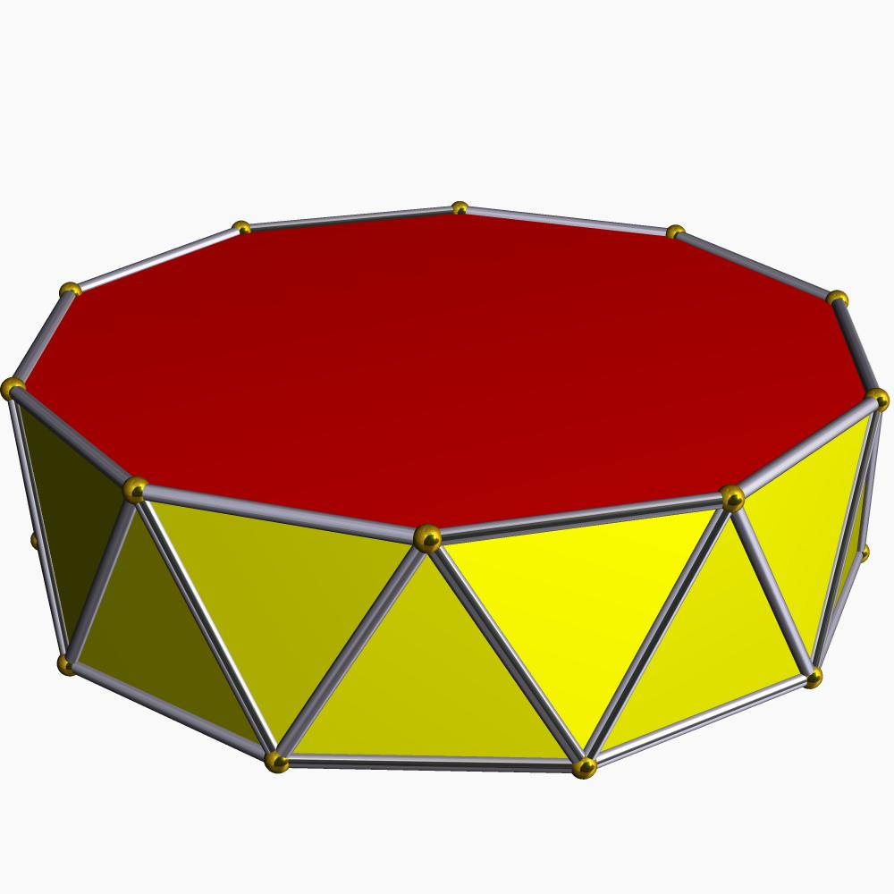
Decagonal Antiprism
20 triangular side faces and 2 decagonal bases.
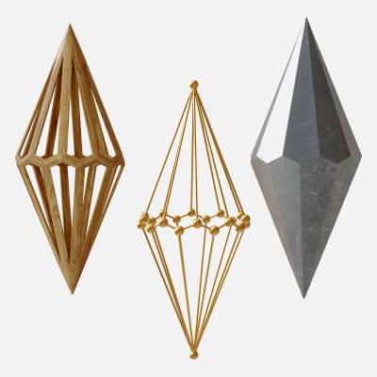
Decagonal Trapezohedron
20 congruent kite-shaped faces.
The Decagonal Trapezohedron is the dual polyhedron of the Decagonal Antiprism.
In this dual relationship:
- Each face of the antiprism corresponds to a vertex of the trapezohedron.
- Each vertex of the antiprism corresponds to a face of the trapezohedron.
- The number of edges remains the same.

Worked Example
# Source: AI Source: Provided by: [Data Path: Persons Table -> ID Column: 1, Name_En Column: Motasem Essam] -> From: [ChatGPT] on [7/25/2026]
Problem: Find the total surface area of a Decagonal Trapezohedron if the diagonals of each kite-shaped face are 6 cm and 8 cm.
Solution:
Step 1: Calculate the area of one kite.
$$A=\frac{1}{2}×6×8$$
$$A=24{\text{ cm}}^{2}$$
Step 2: Multiply by the 20 faces.
$$S=20×24$$
$$\boxed{S=480{\text{ cm}}^{2}}$$
Answer: The total surface area is 480 cm².

Constructing a Decagonal Trapezohedron in Solid Geometry
# Source: AI Source: Provided by: [Data Path: Persons Table -> ID Column: 1, Name_En Column: Motasem Essam] -> From: [ChatGPT] on [7/25/2026]
Required Instruments:
- Ruler.
- Compass.
- Protractor.
- Pencil.
- Drawing paper.
Construction Steps:
- Draw a regular decagon to establish the tenfold arrangement.
- Mark a second set of ten vertices, positioned in a staggered arrangement relative to the first set.
- Place an upper apex above the center of the vertex rings.
- Place a lower apex below the center of the vertex rings.
- Connect the upper apex to the appropriate vertices of the two rings.
- Connect the lower apex to the corresponding vertices.
- Complete the 20 kite-shaped faces.
- Darken the visible edges and use dashed lines for hidden edges.
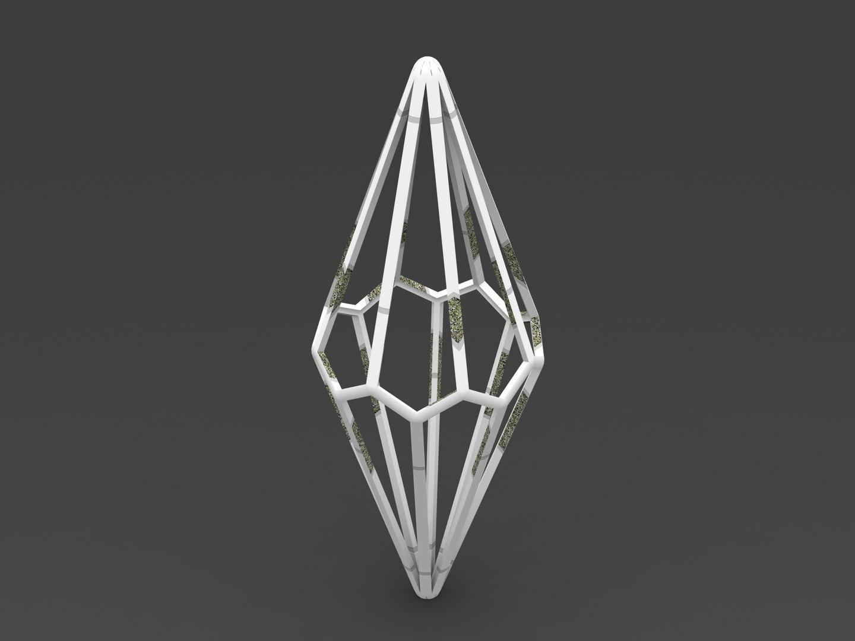

Key Points
# Source: AI Source: Provided by: [Data Path: Persons Table -> ID Column: 1, Name_En Column: Motasem Essam] -> From: [ChatGPT] on [7/25/2026]
- A Decagonal Trapezohedron is a convex polyhedron.
- It has 20 congruent kite-shaped faces.
- It has 40 edges.
- It has 22 vertices.
- It has two opposite apexes.
- It has two staggered rings, each containing 10 vertices.
- It has tenfold rotational symmetry.
- It is the dual of a Decagonal Antiprism.
- Its faces are kites, not trapezoids.

Conclusion
# Source: AI Source: Provided by: [Data Path: Persons Table -> ID Column: 1, Name_En Column: Motasem Essam] -> From: [ChatGPT] on [7/25/2026]
The Decagonal Trapezohedron is a highly symmetrical polyhedron characterized by its 20 congruent kite-shaped faces, two opposite apexes, and tenfold rotational arrangement. Its dual relationship with the Decagonal Antiprism makes it an important example in the study of polyhedral geometry and geometric duality.

